This is a sample policy provided by FFVA Mutual as a service to its policyholders. Terms outlined below mayor may or not be applicable to your business.

(Insert Company Name and/or logo)

Return-To-Work Policy

Objectives

(Company Name) has developed a return-to-work policy. Its purpose is to safely transition employees to employment at the earliest date following any injury or illness. This policy applies to all employees and will be followed whenever appropriate.
- (Company Name) defines transitional work as temporary modified work assignments within the employee’s physical abilities, knowledge, and skills.
- Where feasible, transitional positions will be made available to injured employees in order to minimize or eliminate lost time.
- For any business reason, at any time, we may elect to change the working shift of any employee based on company business needs. [This optional language may be included depending upon your business.]
- The physical requirements of transitional/temporary work will be provided to the attending physician. Transitional/temporary positions are then developed with consideration of the employee’s physical abilities, the business needs of (Company Name), and the availability of transitional work.

Transitional Temporary Work Assignment

If you have a work-related injury and are missing time from work, contact our human resources department for details regarding lost time.

(Company Name) will determine appropriate work hours, shifts, duration, and locations of all work assignments. (Company Name) reserves the right to determine the availability, appropriateness, and continuation of all transitional assignments and job offers.

Communication

It is the responsibility of the employee and/or supervisor to immediately notify human resources of any changes concerning a transitional/temporary work assignment. Human resources will then communicate with the insurance carrier and attending physician as applicable.
Employee responsibilities

Accident Reporting

- An accident is any unplanned event that disrupts normal work activities and may or may not result in injury or property damage. All work-related accidents, injuries, and near misses must be reported immediately to human resources.
- If an accident occurs, but does not require professional medical treatment, the supervisor should immediately be informed so that an accident analysis can be completed. If first-aid treatment is needed, it should be sought on-site.
- If an accident occurs which requires professional medical treatment, the employee should follow the emergency response plan.

Worker’s Physical Condition

- If professional medical treatment is sought, the employee should inform the attending physician that (Company Name) has a return-to-work program with light duty/modified assignments available.
- The employee should obtain a return-to-work release form and completed job analysis form (if available) from human resources. This should be provided to the treating physician and should be returned to human resources following the initial medical treatment.

Worker - Able to Return-to-Work

- If the attending physician releases the employee to return to work, as evidenced by completion of a return-to-work release form and job analysis form, the form(s) must be returned to personnel within 24 hours for assignment of light duty/modified work. The employee must report for work at the designated time.
- The employee cannot return to work without a release from the attending physician.
- If the employee returns to a transitional/temporary job, the employee must make sure that he or she does not go beyond either the duties of the job or the physician’s restrictions.
- If the employee’s restrictions change at any time, he or she must notify his or her supervisor at once and give the supervisor a copy of the new medical release.

Worker - Unable to Return-to-Work

- If the employee is unable to report for any kind of work, the employee must call in at least weekly to report medical status.
- While off work, it is the responsibility of the employee to supply human resources with a current telephone number (listed or unlisted) and an address where the employee can be reached.
- The employee will notify human resources within 24 hours of all changes in medical condition.
Employer responsibilities

Accident reporting

The supervisor will conduct an accident analysis on all accidents, regardless of whether an injury occurs.
Other information will be forwarded as soon as developed, including:
- Name of employee’s attending physician
- Completed return-to-work release form from attending physician and medical documentation, if appropriate
- Completed transitional/modified or regular job analysis
- Job offer letter and responses
- The supervisor will notify the insurance carrier of any changes in the employee’s medical or work status as soon as possible.

Medical Treatment and Temporary/Transitional Duty Physical Condition

- A return-to-work release form and a completed job analysis form (if available) will be provided to the employee to take to the attending physician for completion and/or approval.
- At the time of first medical treatment the return-to-work release form must be completed and returned to human resources. If one is not, human resources will request one from the attending physician.
- The completed return-to-work release form will be reviewed by human resources.
- A temporary/transitional job analysis form will be prepared from information obtained from the attending physician for review and approval.

Job Offer Letter

- Upon receipt of a signed temporary/transitional job analysis form from the attending physician, a written job offer letter will be prepared by the employer. It will be mailed by both regular and certified mail to the employee’s last known address or presented to the employee.
- The letter will note the doctor’s approval and will explain the job duties, report date, wage, hours, report time duration of transitional work assignment, phone number, and location of the transitional assignment.
- The employee will be asked to sign the bottom of the job offer letter indicating acceptance or refusal of the offered work assignment.
- Copies of the job analysis, work release, and job offer letter will be forwarded to FFVA Mutual.

Supervisor Responsibilities

- The supervisor will monitor the employee’s performance to ensure the employee does not exceed the employee’s physician release.
- The supervisor will monitor the employee’s recovery progress through regular contact to assess when and how often duties may be changed. The supervisor will assess the company’s ability to adjust work assignments upon receipt of changes in physical capacities.
Employee Acknowledgment

- The return-to-work policy and procedures have been explained to me.
- I have read and fully understand all procedures and responsibilities.
- I agree to observe and follow these procedures.
- I have received a copy of this policy and procedure.
- I understand failure to follow these procedures may affect my re-employment, reinstatement, and vocational assistance rights.

____________________________________ ____________________________
Employee signature Date

____________________________________ ____________________________
Company Representative signature Date

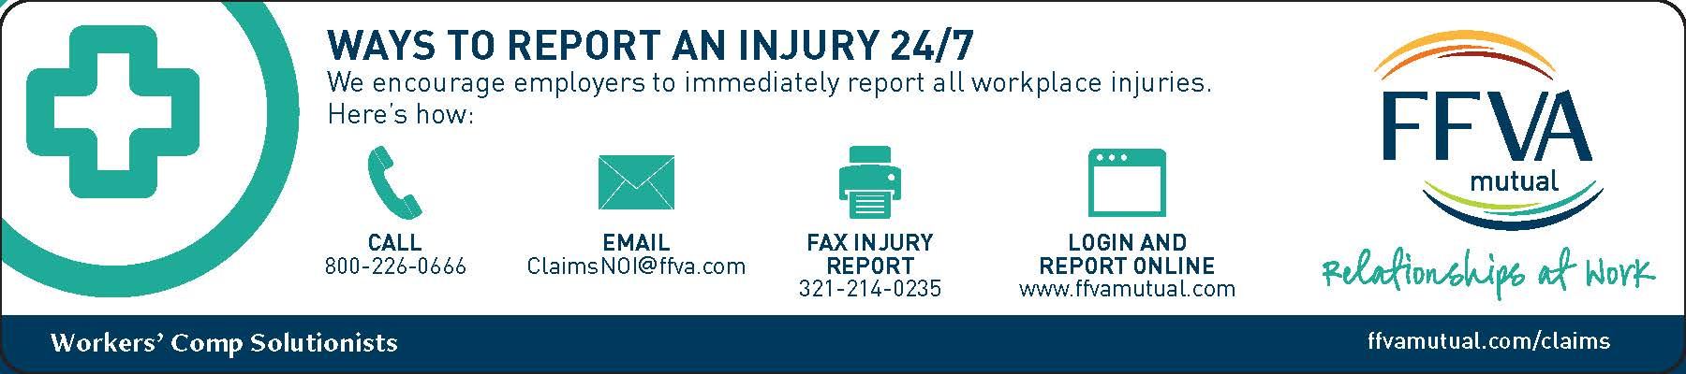

Note: Before implementing a return-to-work policy, you should obtain legal counsel. This document is not designed as a substitute for reasonable accommodation under any applicable federal or state laws, such as Americans with Disabilities Act, The Rehabilitation Act of 1973, or other applicable laws.

To preserve the ability to meet company needs under changing conditions, this company reserves the right to revoke, change, or supplement guidelines at any time with written notice. The policies and procedures in this return-to-work program are not intended to be contractual commitments and they shall not be construed as such by our employees. This policy is not intended as a guarantee of continuity of benefits or rights. No permanent employment for any term is intended or can be implied by this policy.

